AMERICAN HERDING BREEDS ASSN.
AND

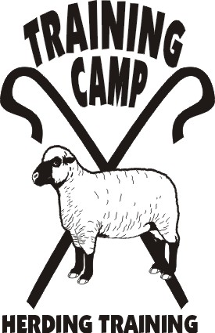

GET READY FOR LOCAL TRIALS

JUNIOR HERDING DOG
HERDING TRIAL DOG

HERDING TRIAL ARENA DOG
HERDING RANCH DOG - MIXED FLOCK

May 18, 2014

LOCATION:

Seaman Farm, Chisago, MN

OPEN TO ALL HERDING AND MIXED HERDING BREEDS
(DOGS AT LEAST 6 MONTHS OF AGE)

TEST CLASS: JHD – Goats
TRIAL CLASSES: HTD I, II, II – Sheep or Ducks
HTAD I, II, III – Ducks
Course 3 w/gather & Shed
HRD MF I, II, III – Sheep/Ducks

ENTRY LIMITS: 15 HTD – Sheep & Ducks total
15 HTAD – Ducks
15 HRD - Mixed Flock
10 JHD

JUDGE: JoAnna Yund & Linda Spengler

MAIL ENTRIES TO:
JoAnna Yund
4047 Sheridan Ave. So.
Minneapolis, MN 55410
joannay@aol.com

ENTRY FEES:
PRE-ENTRY (Due 5/2/14) $30/first run & $25/additional runs
Day-Of (livestock available) $40/run

TRIAL CHAIR: JoAnna Yund
JoAnnaY@aol.com

- Handlers Meeting times will be sent after closing
- Competitors are responsible for cleaning up after their dogs. All dogs must be on leash when not competing.
- Competitors assume financial responsibility for medication and/or veterinary care and/or replacement value of stock for any injury caused by them or their dog(s).
- Handler’s are responsible for sending to trial secretary their AHBA recording forms

DIRECTIONS TO SITE – available at www.trainingcampinc.com

